Lee Ji Heng 李智恒
Dark Light 黑光
Errata List

*** All issues marked in pink. 所有问题都用粉红色标记

General changes include 一般变化包括:
- Font and format changes, including use of small time signatures, as agreed by SCO. 字体和格式的改变，包括使用小拍号，经SCO同意。
- Added English names/text for instruments. 新增乐器英文名称/文字。
- Rehearsal mark at the start has been removed. 开始时的排练标记已被删除
For such edits I have marked some of these in pink but haven’t described them in the errata list below. 对于此类编辑，我已将其中一些标记为粉红色，但未在下面的勘误表列表中对其进行描述。

Errata for Version 1
Bar  小节 | Instrument  乐器 | Issue  问题 | Answer  答案
Start | 加键次中唢  加键低音唢 | Would it be okay to name these CZYSN and DYSN?
1-5 | Strings | Would it be more clear to instead use a crescendo from niente sign instead, and push back the ppp one bar? For example  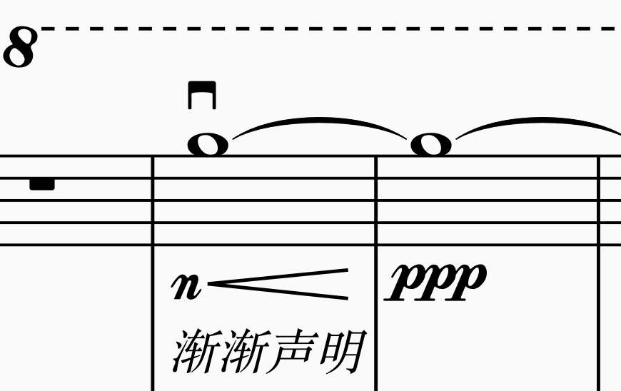
All | Strings | In the strings, there is no key signature and a lot of the notes have intervals such as F# to Db? Would it be more appropriate to use the key signature and use Gb instead of F#? (And only use F# in instances where it is more appropriate such as with occurrences of G natural etc.) I also feel that we could also experiment with using an all sharp key signature, as there are many places in the winds with these intervals as well.
10 | Contrabass  低音提琴 | There are two ties here, what is the purpose of the 2nd tie?
38 | Perc IV, V  打击乐 IV, V | What’s the best way to say the upper half for Bianzhong (like in the Chinese description?)  For Perc V, is there a specific type of gong required? There is another Gong indication at m.85. Is this a different one?
56-59 | Perc I  打击乐 I | Would you like to add ending dynamics for each of these diminuendos?
56-57 | 新笛  XD | Added dim. to mp to match other di.
57-84 | Contrabass  低音提琴 | Contrabass is at ff at m. 57, but cello is at mf. Does this actually continue all the way to m.84. What should the ending dynamic of the crescendo at m.84 be for each?
93 | Perc. | Is the woodblock (Muyu) supposed to be single line staff? [For Sherman – should I keep it as just Muyu or is woodblock preferable?)
93-95, 101-103,  133-134 | Vc, Cb | Removed the ‘tremolo’ text, replaced with tremolo symbol.
111, rehearsal M | Perc. III | Are these cymbals any particular cymbals. There’s another marking for cymbal at rehearsal M, does this refer to a different cymbal?
143-44 | Vc, Cb | Made the tie a dotted tie, since there are two slurs on either side. This is to specify that musical aspect of a tie is required, but technically it is indeed two separate bows.
144 | 中阮  ZR | Added ff to match with other instruments.
148 | GH, EH, ZH | Does the ff happen on specific beat, since it’s placed in the middle? If not, would it make sense to move it to the start of the bar or the next bar?

